5" touchscreen

* Preloaded maps with free lifetime updates
* Lane assist with junction view
* Speaks street names
* Speed limit indicator

With a big 5" (12.7 cm) touchscreen, more than 5 million points of interest (POIs) and spoken turn-by-turn directions, nüvi 50LM makes driving fun again. Plus, with FREE lifetime map updates, you always can keep your roads and POIs up to date.

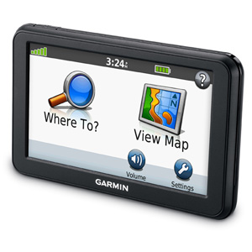

Get Turn-by-turn Directions

nüvi 50LM’s intuitive interface greets you with 2 simple choices: “Where To?” and “View Map.” Touch the screen to easily look up addresses and services and to be guided to your destination with voice-prompted, turn-by-turn directions that speak street names. It comes in 2 mapping versions and has preloaded maps for the lower 49 states plus Puerto Rico, or full coverage of the U.S. and Canada. nüvi 50LM’s speed limit indicator shows you how fast you can go on most major roads. With its “Where Am I?” emergency locator, you always know your location. It also comes preloaded with millions of POIs and offers the ability to add your own.